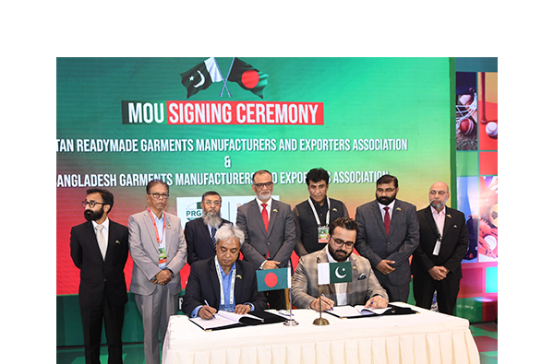

BGMEA and PRGMEA sign MoU to strengthen bilateral trade cooperation in apparel and textiles

The Bangladesh Garment Manufacturers and Exporters Association (BGMEA) and the Pakistan Readymade Garment Manufacturers and Exporters Association (PRGMEA) have signed a Memorandum of Understanding (MoU) to enhance and promote trade and investment between Bangladesh and Pakistan.

BGMEA Administrator Anwar Hossain and PRGMEA Vice Chairman-Central Aamir Reyaz Chottani inked the MoU on behalf of their respective associations on April 28 at the InterContinental Dhaka.

Commerce Adviser SK Bashir Uddin, Pakistan’s High Commissioner to Bangladesh Syed Ahmed Maroof and business leaders from Bangladesh and Pakistan were present at the MoU signing ceremony.

Under the agreement, both associations will explore avenues for mutually beneficial cooperation, with a focus on knowledge exchange, industrial collaboration, exchange of business delegations, participation in trade exhibitions.

The MoU emphasizes the shared objective of driving sustainable growth, enhancing competitiveness, and leveraging the complementary strengths of both countries’ garment and textile industries.

This collaboration aims to unlock new opportunities and promote deeper engagement between the two major players in the global apparel market.